Consumer Perception Survey (CPS)
For Older Adults
May 20-24, 2024
[Counties/providers may tailor this flyer as needed.]
Tell us what you think about the services you are receiving at this program.
Complete a voluntary, anonymous and confidential survey. Choose how you want to participate:
Secure online survey link for this program:
OLDER ADULT
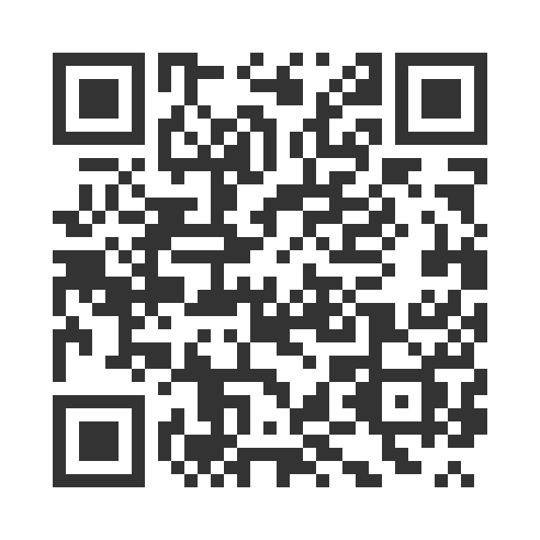
https://uclahs.fyi/Older

OLDER ADULT (+QOL)
https://uclahs.fyi/OlderQOL
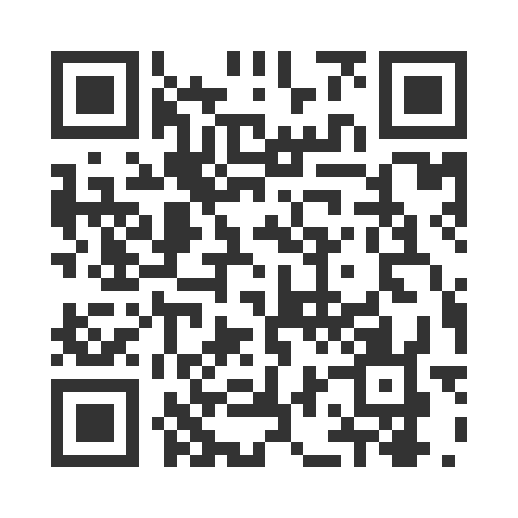

- Paper survey form (ask program staff for a form)
Ask program staff if you have questions or would like assistance with the survey!
Thank you for participating in this important survey!

